Pastor Scott Baker 2.4.24

When it comes to life and what we believe about life, from the moment of conception until our final breath, that belief must be formed from what God’s Word states. It Is our source of **__________.**

**What should we believe about life?**

**1. Life is a __________ from God. (v.13, 15-16a)**

God is the **_______________** of all life.  
God created **__________** single part of us down to the very last detail!

Human beings are unlike any other living thing – we are created in the **____________** of God! **(Genesis 1:27)**

God designed and created you to be **_______________** what He wanted you to be! This tells us we are not mistakes! We are not accidents! We are valued and treasured individually designed **___________________**! **(Job 10:8**; **Acts 17:25)**

Parents are only **___________________** that God uses!

Scripture teaches us that God both closes and opens the **__________!**

**(Genesis 30:1-2**; **30:22-24**)

Children are a **__________** from God! **(Psalm 127:3-5)**

**How do we respond to what we believe about life?**

**1. Life is to be ___________________! (v.14)**

Simply put, **____________** is the proper response to the gift of life!

As created beings, we are living and breathing **_______________** of the creative power of God! The human body and all of its complexities should make people just stop in **________** of what God has done!

Every day we are alive, we should be **____________** and celebrate!

**(Psalm 118:24)**

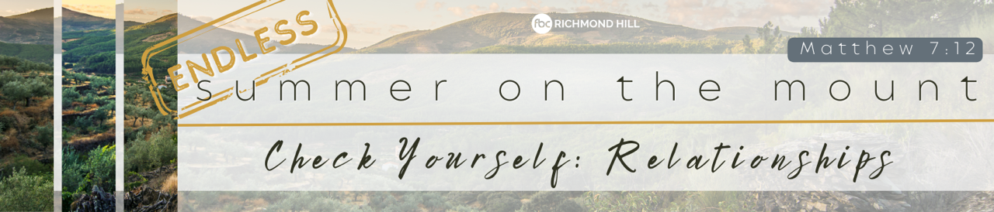

**2. We need to learn to E_______________!**

We can be so quick to **_______________** and so slow to encourage. It’s easy to pick someone apart, God wants us instead to be **_____________** others up! **(Ephesians 4:29**; **Hebrews 10:24-25)**

**3. We need to learn to A_______________!**

How often do we say **__________** **_______** to those who have made a difference or some kind of positive impact in our lives?

**(Ephesians 1:16)**

Being thankful is a part of God’s **_________** for us. **(1 Thess. 5:16-18)**

**4. We need to learn to R_______________.**

**(1 Peter 5:5**; **1 Thessalonians 5:12)**

We need to **______________** people and the gifts and abilities God has given them.

**5. We need to learn to N_______________.**

We were not created to do life alone! God created us to do life with others, to be in **_______________**!

**(Hebrews 10:24-25**; **Romans 12:13-17**; **Romans 12:4-5)**

We need each other. We are one in the body of Christ. He has put us together and expects us to be **____________**, to live in harmony, despite our differences.

We all have our role to play in the body! God has uniquely designed and gifted us as He sees fit. **_______________** we can accomplish great things for Him!