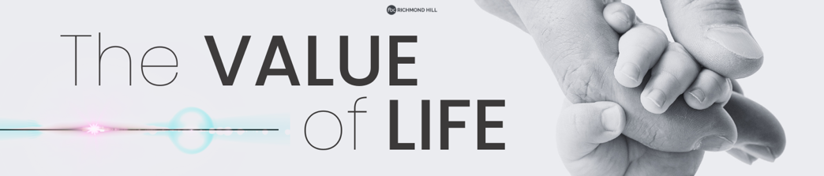Pastor Scott Baker 1/19/25
When it comes to life and what we believe about life, from the moment of conception until our final breath, that belief must be formed from what God’s Word states. It Is our source of __________.

What does God’s Word say about life?
1. All life is from __________! (Psalm 139: 13,15-16a)
God is the _______________ of all life!
God was personally involved with creating __________ one of us!
We now know such things as:
_____ days after conception the baby has a heartbeat.
_____ weeks after conception the baby’s brainwaves can be measured.
_____ weeks after conception, the stomach, liver, and kidneys of the baby are functioning, and their fingerprints have formed.
_____ weeks after conception the baby can feel pain – all this while being about the size of a bean!
_____ weeks after conception the arms, hands, fingers, feet, and toes are fully formed!

God designed and created you to be _______________ who He wanted you to be! (Job 10:8; Acts 17:25)
In the Bible, we have several examples of life being affirmed while the _______________ baby is in the womb. (Judges 13:3-5; Luke 1:39-45)

Pastor Scott Baker 1/19/25
When it comes to life and what we believe about life, from the moment of conception until our final breath, that belief must be formed from what God’s Word states. It Is our source of __________.

What does God’s Word say about life?
1. All life is from __________! (Psalm 139: 13,15-16a)
God is the _______________ of all life!
God was personally involved with creating __________ one of us!
We now know such things as:
_____ days after conception the baby has a heartbeat.
_____ weeks after conception the baby’s brainwaves can be measured.
_____ weeks after conception, the stomach, liver, and kidneys of the baby are functioning, and their fingerprints have formed.
_____ weeks after conception the baby can feel pain – all this while being about the size of a bean!
_____ weeks after conception the arms, hands, fingers, feet, and toes are fully formed!

God designed and created you to be _______________ who He wanted you to be! (Job 10:8; Acts 17:25)
In the Bible, we have several examples of life being affirmed while the _______________ baby is in the womb. (Judges 13:3-5; Luke 1:39-45)

All life is from God and should be considered life from the moment of conception because God considered all of us even ____________ our conception! (Jeremiah 1:5)
What does God’s Word say about life?
2. All life is to be _______________! (Psalm 139:14-16)
We value life by…
1) ___________________ it!
We are to be grateful to God for giving us life and that He Himself created each one of us in His __________! (Genesis 1:27)
_______________ are a gift from God! (Psalm 127:3-5)
Every day we are alive, we should be grateful and be ________! (Psalm 118:24)

We value life by…
2) ________________ living it!
Before we were born, before we were conceived, before we were created, God had a ______________ for our lives! (Jeremiah 29:11)
God expects us to make the most of the time He has given us! Make sure your life is being used for the __________ God!

We value life by…
3) ________________ It!
The womb is supposed to be a ________ place for life! (Psalm 32:7)
We must share the truth that the taking of innocent life, even in the womb, is ____________ and God’s Word forbids this! (Exodus 20:13)
From the time of ________________ until final breath and we must do all that we can to value and protect life! (Proverbs 24:11-12)
We must also do all that we can to _____________ and help those ministries that exist to love and support families who have unexpected and unwanted pregnancies.

All life is from God and should be considered life from the moment of conception because God considered all of us even ____________ our conception! (Jeremiah 1:5)
What does God’s Word say about life?
2. All life is to be _______________! (Psalm 139:14-16)
We value life by…
1) ___________________ it!
We are to be grateful to God for giving us life and that He Himself created each one of us in His __________! (Genesis 1:27)
_______________ are a gift from God! (Psalm 127:3-5)
Every day we are alive, we should be grateful and be ________! (Psalm 118:24)

We value life by…
2) ________________ living it!
Before we were born, before we were conceived, before we were created, God had a ______________ for our lives! (Jeremiah 29:11)
God expects us to make the most of the time He has given us! Make sure your life is being used for the __________ God!

We value life by…
3) ________________ It!
The womb is supposed to be a ________ place for life! (Psalm 32:7)
We must share the truth that the taking of innocent life, even in the womb, is ____________ and God’s Word forbids this! (Exodus 20:13)
From the time of ________________ until final breath and we must do all that we can to value and protect life! (Proverbs 24:11-12)
We must also do all that we can to _____________ and help those ministries that exist to love and support families who have unexpected and unwanted pregnancies.

